For Immediate Release
June 19, 2021
Contact: Molly Allard, mallard.nricd@gmail.com
Area Students Celebrate The Wildlife Of The Scituate Reservoir Watershed In Annual Poster Contest
The Scituate Reservoir Watershed Education Program (SRWEP) Poster Contest is an annual tradition for elementary and middle school students in Scituate, Foster, Glocester, Johnston, and Providence. In 2021 many aspects of the Scituate Reservoir Watershed Education Program remained on hold, but the watershed poster contest continued to attract over 200 beautiful entries from area elementary schools and homeschoolers. Students were given a video about the year’s theme, “Wonderful Watershed Wildlife,” and though SRWEP staff were unable to visit classrooms directly before the contest, their devoted teachers provided excellent background about the Scituate Reservoir watershed to help them prepare. Five elementary schools participated in this year’s contest; those that were unable to participate during this unusual year, as well as area middle schools, anticipate a return to the contest in 2022.
The poster contest’s usual judges, Betsy Dake of the Rhode Island Department of Environmental Management, Paul Dolan of the Rhode Island Resource Conservation and Development Council, and Rich Blodgett of Providence Water, once again judged posters online and were extremely impressed with the quality of the posters submitted. All school winner and honorable mention posters will be featured in a 2022 “Wonderful Watershed Wildlife” calendar that will be distributed free of charge throughout the Scituate Reservoir watershed communities of Foster, Glocester, Scituate, and Johnston beginning in autumn 2021. “Wonderful Watershed Wildlife” celebrates the amazing animals that call the protected public lands and managed private lands of the area home, and the important benefits that these habitats have for both water quality and biodiversity.
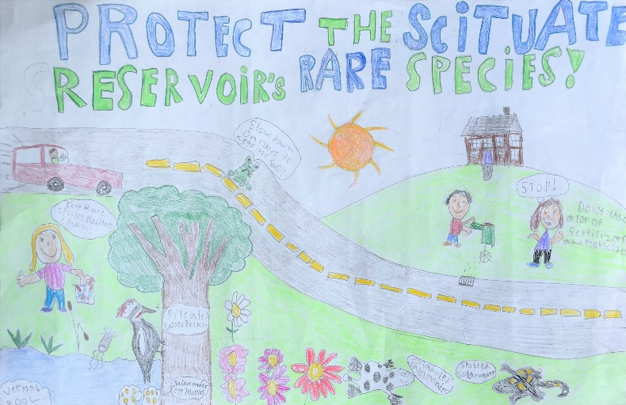
The Scituate Reservoir Watershed Education Program (SRWEP) is an environmental education and community engagement partnership between Northern RI Conservation District and Providence Water. Regular programs presented by SRWEP include elementary school classroom visits, the elementary school Water Festival, educational partnerships with area high schools, the Neighbor to Neighbor new resident mailing program, workshops and webinars related to water quality for adult residents, and partnerships to help support forest landowners with watershed stewardship activities. You can learn more by following SRWEP on Facebook or visit landwaterconnection.org.
Grand Prize Winner
Noelle Sutter, Mrs. DiLuglio’s Class, North Scituate Elementary School
Noelle’s beautiful and detailed poster showcases many of the wonderful animals that call the Scituate Reservoir home such as marbled salamanders and pileated woodpeckers. She also highlights the importance of vernal pool ecosystems and gives a few tips that residents can follow to help protect the beautiful watershed they live in and its animal residents.

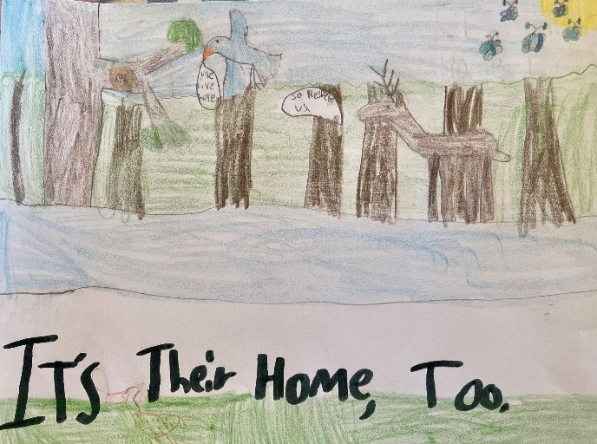
Matilda Shippee
Homeschool Division Winner
Grade 3, Foster

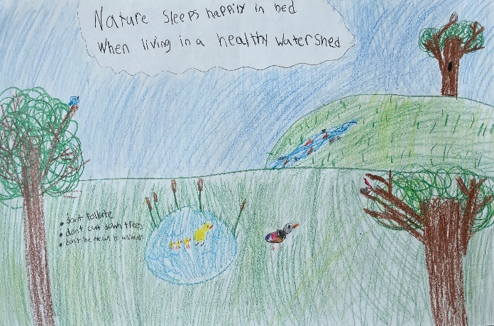

Asher
Clayville Elementary School Winner
Miss Colvin’s Class

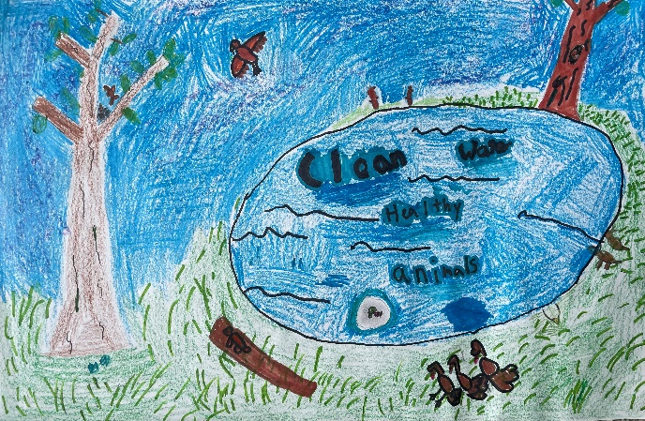
Ayden Waugh
West Glocester Elementary Winner
Ms. Jordan’s Class

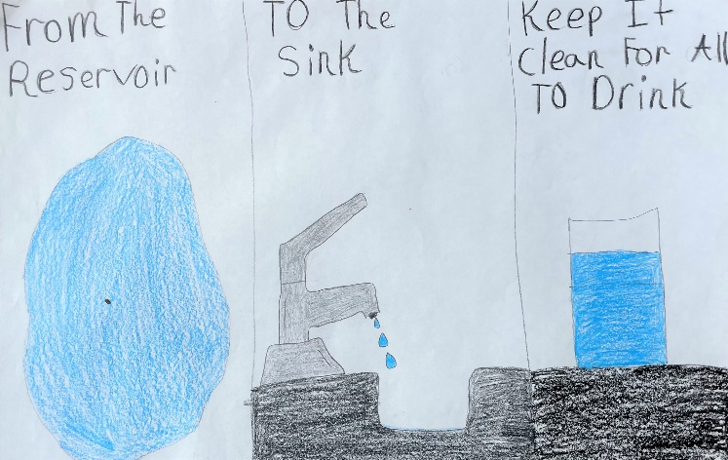

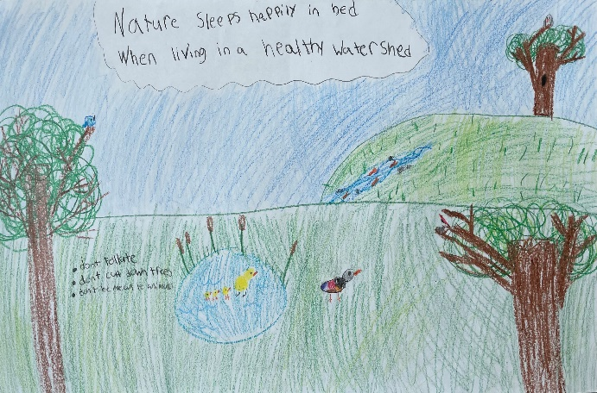
Olivia Vetri
Captain Isaac Paine Winner
Mrs. Catullo’s Class
Honorable Mention Winners: Lily-Clayville Elementary (Miss Colvin), Sofia-North Scituate Elementary (Mrs. DiLuglio), Daniella DelSesto-Clayville Elementary (Miss Colvin), Bridgette-North Scituate Elementary (Mrs. DiLuglio), Ethan Greathouse-West Glocester (Ms. Jordan), Declan Hayle-Hope Elementary (Miss Loffredo), Mackenna-North Scituate Elementary (Mrs. DiLuglio), Jaylyn Matos-Clayville Elementary (Miss Colvin), Jake-Captain Isaac Paine (Mrs. Catullo), Rosalie-North Scituate Elementary (Ms. Caldarone)
Nora
Hope Elementary School Winner
Miss Loffredo’s Class

